ABOUT THE ARTIST
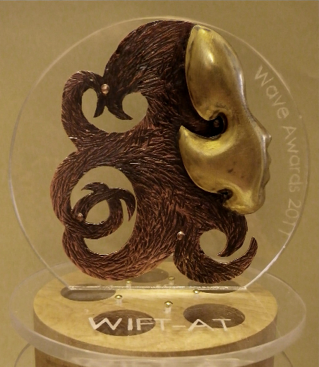
The WAVE Awards are an opportunity to honour deserving women in the film and television industry in Atlantic Canada. Talented, creative women are also behind the scenes of the awards - including Fredericton artist Kristianne Levesque.
Kristianne has been designing and producing the awards for five years now and having been asked to design an award celebrating women in the arts, meant a lot to her.
“It’s important to me to work with a group that I can relate to. I appreciate it so much that they came to me.”
To get some inspiration when first designing the award, Kristianne looked into the history and the significance of the WAVE Awards. Kristianne designed the award to be the profile of a woman, with hair mimicking waves, as a nod to both the award name, and the Atlantic region. The base is plexiglass, with a wooden film reel.
Kristianne works at home, in a studio space she’s built in her backyard. A trained metalsmith, Kristianne designs jewellery, but especially enjoys designing bigger, sculptural pieces like the WAVE awards. She also designs urns and trophies. With three young kids, Kristianne is very busy, but is hoping to transition to working on her art full time soon.
Kristianne often gets her inspiration from nature and being outside. She also keeps all her old sketchbooks, and looks back at them from time to time to get ideas. “Looking back at older sketches, it can bring a whole new meaning,” she says.
2015 WAVE nominations are due February 2nd, 2015. Learn more at: http://www.wift-at.com/waveawards

